Chapter 2, Problem 48.

Convert the circuits in Fig. 2.112 from Y to Δ.
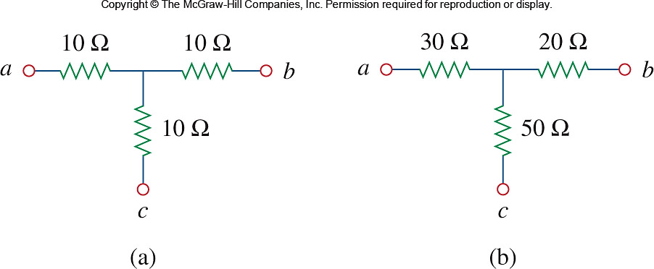

Figure 2.112
For Prob. 2.48.

